**=====THIS REQUIRES MATLAB TO USE=====**

I’m currently working on a way to highlight the areas of a given image to signify bad crop fields or good crop fields. Currently I’m just messing with things as a proof of concept to show what progress I’ve made so far.

Currently, I have made it so you can take a given crop field segment and “darken” the areas suspected of being bad crops and “erase” the areas that aren’t part of the field, or are obviously not bad crops.

**USING THE PROGRAM:**

1. Run MATLAB and place all these files in the same directory.
2. In the MATLAB command window, just type in “proof_of_concept” and everything should run for you. This is a driver file.
3. You should now see two figures (they may be stacked on top of each other, so move the windows), one of the image before using the binarify function I wrote, one after.

**HOW THE PROGRAM WORKS:**

1. It takes a given image and loads it into MATLAB.
2. This image is then turned to grayscale (I haven’t worked on color images yet. I will get on it though.)
3. The program will then run this image through the “binarify” script I wrote.
4. Binarify looks at an image and checks it’s pixel color values for every pixel.
5. If a given pixel color value is gauged as too white (around value 231+ on grayscale), it’s likely to either be a good crop, or something else.
6. If a value is between 20 and 150, it’s likely to be a bad crop. These values are then turned to 20, making them close to black on the grayscale, highlighting the bad crops, hopefully.

**WHAT STILL NEEDS TO BE DONE:**

None of these values are hard examined, they are just “guesses” at what is a good crop, what is a bad crop. More research into the values has to be done to be sure of anything. I’m also working on getting this to work on OpenCV + Java so that it’s more portable between team members and the customer.

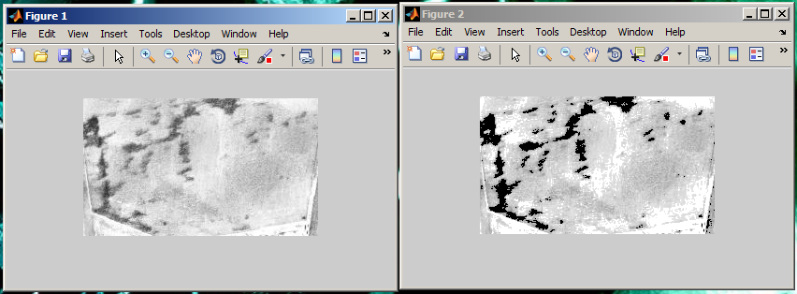

(Sample test image)

If you would like to modify the code, go for it. It’s all commented with what’s said here in the Standard Operating Procedure/Read Me.

**-Patrick Thavornkant**